Space Balloon 2

Project Report

Noah ALLAN

*<*[nallan@stromeros.co.uk](mailto:nallan@stromeros.co.uk)*>*

June 2021

Balloon 2 Project Report

Table of Contents

1 Introduction 2

1.1 Overview 2

1.2 The Team 2

2 Identify 3

2.1 Specification 3

2.2 Inputs 3

2.3 Outputs 3

3 Analysis 4

3.1 Abstraction 4

3.2 Project Break Down 4

3.2.1 Phase One – Feasibility 4

3.2.2 Phase Two – Pre-Launch 5

3.2.3 Phase Three – Launch 5

3.2.4 Phase Four – Recovery 6

3.2.5 Phase Five – Post-Launch 6

3.3 Equipment 6

References 8

# 1 Introduction

## 1.1 Overview

* The aim for this balloon is to send a box filled with environmental sensors and cameras to 100,000 ft (approximately 30 km) and descend back down to earth with the use of a parachute. Using a radio transmitter live data will be sent back down to earth for display on a live stream via the YouTube platform.

## 1.2 The Team

* Supervisors
  + Mr. Challinor
  + Al Stepney
* Back-end:
  + Balloon Software – Corin Malandain and Lluc Ambros
  + Balloon GPS and Data Sending – Evelyn Starbuck and Dean Cooke
  + Ground Station and Data Receiving – Will Armitage and Kaie Pepel
* Front-end:
  + Data Representation - Noah Allan and Finlay Purdie

# 2 Identify

## 2.1 Specification

* For the Balloon Two we must send a helium balloon to a minimum of 100,000 ft (30 km) with a payload filled with various sensors and other devices including cameras and tracking gear for retrieval. There must be a display for all the information to be broadcast down back to earth with a maximum latency of 30 seconds from real time action.

## 2.2 Inputs

* Temperature
* Humidity
* Pressure
* UV light levels
* Dust levels
* CO2 levels
* VOC levels
* O Zone levels
* Location
* Altitude
* Photos

## 2.3 Outputs

* Graphs of the following:
  + Temperature
  + Humidity
  + Pressure
  + UV light levels
  + Dust levels
  + CO2 levels
  + VOC levels
  + O Zone levels
* Text output on the Stream:
  + Altitude
  + Latitude
  + Longitude
  + Time
* Information to be saved on the Black Box file:
  + Index,
  + Latitude,
  + Longitude,
  + Altitude,
  + Time,
  + Temperature,
  + Pressure,
  + Humidity,
  + Carbon Dioxide Levels,
  + Carbon Monoxide Levels,
  + Ozone,
  + Nitrous Oxide Levels,
  + Oxygen Levels,
  + Dust Levels,
  + Light Levels,
  + UV Light Level,

# 3 Analysis

## 3.1 Abstraction

* Data is gathered from the eight sensors and the other data capture devices and is sent to the Raspberry Pi [Rasp Pi] to be turned into a file which can be sent back to the command centre via the radio transmitter. When it arrives on the ground a computer will decode it and turn it into a *CSV* (Comma Separated File) which can be sent straight to the stream computer to be turned into a graph or a text file to be displayed on the stream.

Figure One – A visual representation of the balloon gathering data to it being displayed to the stream.

## 3.2 Project Break Down

### 3.2.1 Phase One – Feasibility

* The feasibility of this project has been pre-determined as the first launch in the summer of 2019 was a partial success. Due to a droppage at launch the tracking system malfunctioned causing the balloon, with the payload, to be lost shortly after launch when it left the sight of the school. Almost 6 months later it was found by a passer-by. The short comings of this launch have been considered and extra measures have been taken to avoid a similar error to occur, including 3 tracking systems rather than just one.

### 3.2.2 Phase Two – Pre-Launch

* The creation of the balloon with all the necessary equipment
* The creation of a live broadcast system
* Testing of all the sensors on earth
  + Sensors tested on the site,
  + Tracking system tested partially off site,
  + Altitude system tested off site,
  + Communication system tested partially off site,
  + Graphical interface tested on site,
* Preparing for errors which may occur and have measures in place to prevent those errors from ruining the mission.
* A document must be created with all the possible errors and accidents and how to fix or deal with them.

### 3.2.3 Phase Three – Launch

* Balloon Launch will need to be launched with ideal weather conditions to ensure the balloon stays away from areas we cannot retrieve (The English Channel to the south), or in an area which is dangerous for aviation (London Gatwick Airport). Figure One (Bellow) shows the area where the balloon must land for retrieval.
* At the launch, the balloon must not be dropped (as happened in the 2019 launch)
* There will need to be three groups of people working on different jobs on the day of the launch:
  + Group One will be focused on the command centre where the data from the balloon will be sent, processed and displayed on the YouTube live stream.
  + Group Two will be focused on the initial launch at ground zero.
  + Group Three will be focused on the retrieval and live tracking of the balloon.

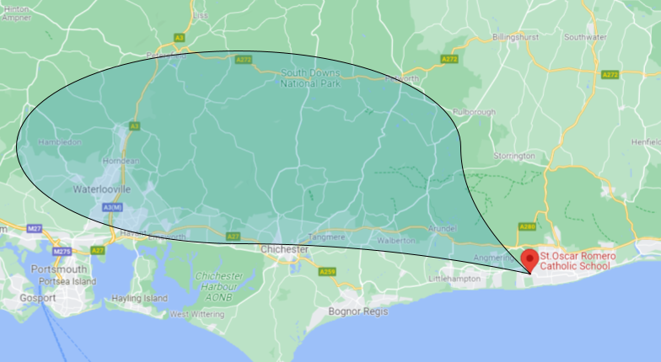

Figure One – Showing the area in which the balloon can land.

### 3.2.4 Phase Four – Recovery



### 3.2.5 Phase Five – Post-Launch

## 3.3 Equipment

A balloon will be sent up with the following sensors and other measuring equipment:

* Raspberry Pi to be the main computer for the payload [Rasp Pi],
* Sensors to detect the following substances:
  + Temperature [Sense HAT]
  + Humidity [Sense HAT]
  + Pressure [Sense HAT]
  + UV Light [Parallax 28091]
  + Dust and other small particle [Sharp GP2Y]
  + Concentration of CO2 [MG-811]
  + VOCs [Adafruit BME680]
  + Ozone and NO2 [MQ-131]
* Tracking equipment,
* Cameras:
* Helium balloon to take the payload to a minimum of 100,000ft (30km),
* Insulated box to house all the payload,
* Parachute to bring the payload back to earth safely and in one piece,

# References

|  |  |
| --- | --- |
|  |  |
| [Adafruit BME680] | Adafruit BME680 contains temperature, humidity, barometric pressure, and VOC gas sensors.  <https://www.adafruit.com/product/3660> |
| [MG-811] | MG-811 Gas (CO2) Carbon Dioxide Sensor. <https://www.sainsmart.com/products/mg-811-gas-co2-carbon-dioxide-sensor> |
| [MQ-131] | Sensors for detecting Ozone gases and Nitrogen Dioxide (NO2).  <https://www.sainsmart.com/products/mq-131-gas-sensor-ozone-module> |
| [Parallax 28091] | Parallax 28091 UV Light Sensor measures ambient ultraviolet intensity in the 200 to 370 nanometre range, including solar ultraviolet UVA, UVB, and UVC light.  <https://www.mouser.co.uk/ProductDetail/Parallax/28091?qs=Cb2nCFKsA8ocEJSQCpJBhQ%3D%3D> |
| [Rasp Pi] | Raspberry Pi is the main computer for the payload dealing with communication with the command centre.  <https://www.raspberrypi.org/products/raspberry-pi-4-model-b/> |
| [Sense HAT] | Following sensors: Gyroscope, Accelerometer, Magnetometer, Temperature, Barometric pressure, and Humidity.  <https://www.raspberrypi.org/products/sense-hat/> |
| [Sharp GP2Y] | Dust sensor Sharp GP2Y1010AU0F is for detecting fine particle larger than 0.8μm in diameter. <https://thepihut.com/products/dust-sensor> |
|  |  |
|  |  |
|  |  |
|  |  |
|  |  |
|  |  |